Electromagnetism

Iran university of science and technology

**Capstone: Electromagnetism - Project Report**

Parmida Haddadnejad

Fall 2022

1. The system consists of two conducting cylindrical plates that are filled with mica, a material with a dielectric constant ϵ0. Mica is chosen as the dielectric material due to its excellent insulating properties and high resistance to electrical breakdown. The dielectric constant ϵ\epsilonϵ of mica plays a crucial role in the electrostatic behavior of the system, as it influences the distribution of the electric field between the plates.

These cylindrical plates are modeled to simulate a parallel-plate capacitor configuration, where the mica dielectric material fills the space between the plates. The conducting nature of the plates allows for the accumulation of charge, while the dielectric material affects the capacitance by altering the electric field between the plates. The simulation will examine how the dielectric constant ϵ\epsilonϵ impacts the potential distribution, electric field, and overall capacitance of the system.

This setup allows for a detailed analysis of electrostatic phenomena in a system with a cylindrical geometry and a dielectric material, providing insights into the effects of material properties on the electric field and potential.

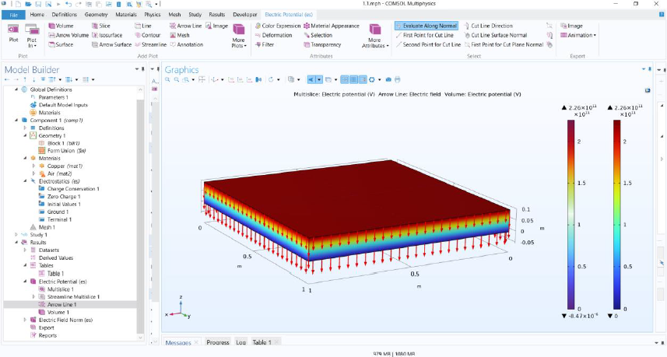

Figure 1

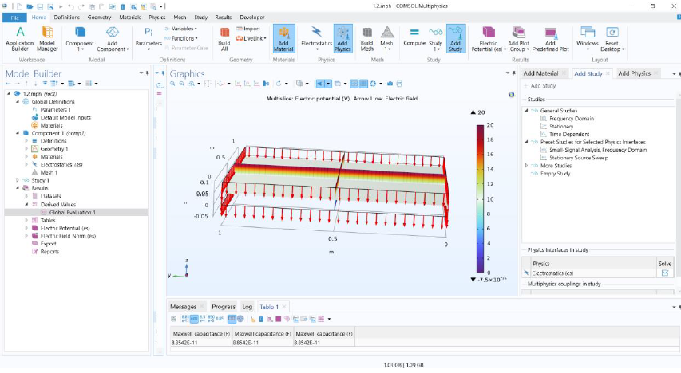

Figure 2

1. For this simulation, we define two coaxial cylinders with a height of 1 unit. One of the cylinders has a radius of 1 unit, and the other has a radius of 0.5 units. To create the required geometry, we use the **Booleans and Operations** feature in COMSOL. By selecting the **Difference** operator, we subtract the inner cylinder from the outer one, thus forming a hollow cylindrical structure.

Once the geometry is defined, we assign the material properties. The entire region is filled with mica, which is selected as the dielectric material due to its insulating properties. The internal and external surfaces of the hollow cylinder are modeled as copper, a conductive material, to simulate the conducting nature of the plates.

For the physics setup, we choose the **Electrostatics** module, as the problem deals with electrostatic fields. One of the copper surfaces is designated as the **Terminal** with a voltage of 20 volts, while the other copper surface is selected as the **Ground**. These boundary conditions allow for the application of an electric potential difference across the two conducting surfaces, creating the conditions for studying the electrostatic field.

To achieve a more accurate solution, it is essential to use a fine mesh. A finer mesh ensures that the results are more precise by resolving the electric field and potential distribution with greater detail.

Next, we select the **Stationary** study type, as the problem involves a static electrostatic scenario. After setting up the study, we run the simulation to compute the electrostatic field.

In the **Results** section, we create a **Volume Plot** under the **Electric Potential** subsection. This plot visualizes the electric potential distribution across the defined region. Additionally, we generate field lines (arrow lines) to illustrate the electric field between the inner and outer surfaces of the cylindrical structure. These visualizations provide a clear representation of the electrostatic behavior of the system.

Finally, to determine the capacitance, we navigate to the **Derived Values** section in **Results** and use the **Global Evaluation** tool. By searching for **Maxwell Capacitance** and evaluating it, we obtain the capacitance value of the system, which answers the question posed in the problem.

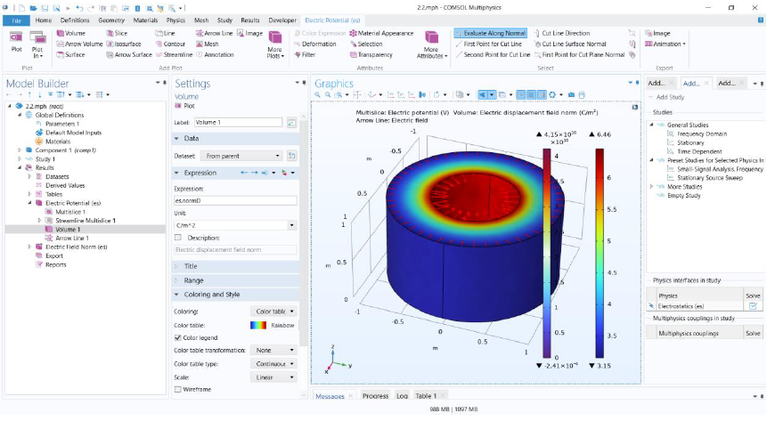

Figure 3

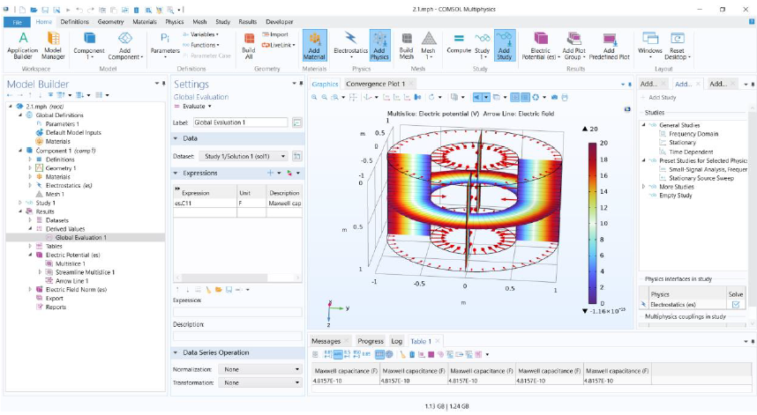

Figure 4